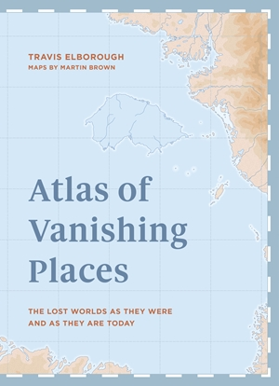
ATLAS OF VANISHING PLACES
The lost worlds as they were
and as they are today

BY TRAVIS ELBOROUGH
MAPS BY MARTIN BROWN

3rd September 2019 | White Lion Publishing | £22.00 Hardback & Ebook

Vanishing places are very real and maps offer us a chance to see how our world looks today, and how it once looked. But what about the places that are no longer mapped? Cities forgotten under the dust of newly settled land. Rivers and seas whose changing shape has shifted the landscape around them. Places that have seemingly vanished without a trace.

“The screen and the swipe, if showing us more of the world, can somehow simultaneously shield us from the truth about its increasing vulnerability. What follows on tactile paper and in print, and through words and pictures, if even perhaps accessed digitally, is a survey of landscape and locations transformed by circumstances; some much disputed, or improbable and entirely unexpected; others, depressingly, almost grimly predictable. As such it ideally serves as a reminder of the mutability of existence but also a clarion call for the urgency of preserving what we hold dear for generations to come.” Travis Elborough

Let Travis Elborough take you on a voyage across every continent to all corners of the world in search of the lost, disappearing and vanished. Martin Brown’s specially commissioned cartography showing each place as it once was and how it is today, alongside intriguing archive images, brings these incredible stories to life. Ancient cities, forgotten lands, shrinking places and threatened worlds – visit them all in the Atlas of Vanishing Places.

Travis Elborough is an author and social commentator, described by The Guardian as ‘one of Britain's finest pop cultural historians’. His books include A Traveller’s Year, A London Year, Being A Writer, A Walk in the Park: The Life and Times of a People’s Institution, Our History of the 20th Century: As Told in Diaries, Journals and Letters, The Bus We Loved, The Long Player Goodbye, and Atlas of Improbable Places. A regular contributor to national print and broadcast media, he has penned articles on all aspects of travel and culture, from pirates in the Caribbean to donkeys at the British seaside and The Rise and Fall of the Antique. Travis lives in London and is available for interview. traviselborough.co.uk

Atlas of Vanishing Places is part of a series published by The Quarto Group



Praise for Atlas of Improbable Places:

“understatedly expressive” - New York Times

“this engrossing book traverses the heights and depths, the beauty and terror, of our world.” - The Observer

“a brilliant guide to places we are never likely to take the family on holiday but still rather hanker to see.” - The Spectator

“a delightful compendium of the strangest places on the planet” - Daily Telegraph

Praise for Atlas of the Unexpected:

“Travis Elborough writes about a wide range of subjects with originality, learning and charm. Atlas of the Unexpected...is seductively beautiful: an inspiring, dream-inducing guide to almost four dozen “haphazard discoveries, chance places and unimaginable destinations” - New Statesman ‘Best books of 2018’

“the writer’s nose for detail and knack for storytelling make for first-class armchair travel.”- South China Morning Post Magazine

“a fun collection of fascinating and peculiar case studies which will take you all the way to the furthest reaches of the planet - presented in a chic, minimalist and aesthetically pleasing way.” - Geographical magazine 'Perfect mapping books for Xmas’

“a delight for any traveller, be they of the armchair variety or an intrepid adventurer.” - Hackney Citizen

“Geography to dip into at your fingertips. A real treat.” - Curiosity Bookshop

For further information and any requests please contact:
Mel Odusanya | melody.odusanya@quarto.com | 0207 284 9362

